Characterization of the Northwest Coast Native Art Ovoid

By: Nathaniel P. Wilkerson

July 10, 2010

Probably the most predominant design unit in the art work, the Ovoid takes many shapes and forms. In theory the ovoid is almost always perfectly symmetrical about the vertical axis, hence the use of templates by most artists when constructing ovoids and designing with them. Pre-contact templates where constructed of bark and folded down the middle before cutting to shape.

The purpose of this study is to develop a more formalized definition of the ovoid in modern mathematical terms and to provide a simple algorithm for generating these curves for future artists. The term ovoid or oval is a very general term and not well defined. It encompasses a large family of curves and is usually defined as any curve resembling an egg or ellipse but not an ellipse. More specifically a northwest coast ovoid is bilaterally symmetrical with a characteristic convex upper side and a slightly concave lower side. See Figure 1 below for an example of a typical northern style ovoid.

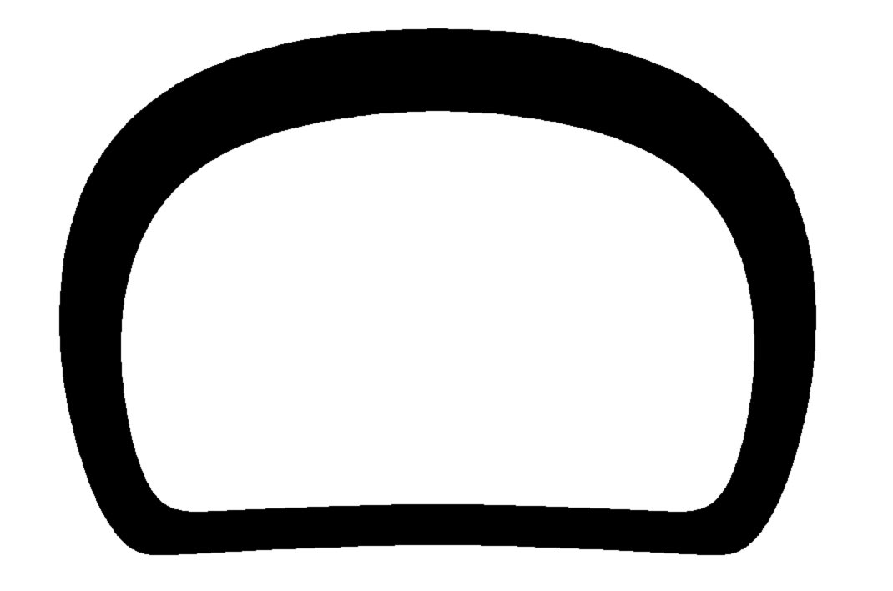Figure 1: Typical Northern Style Ovoid (Artist: Freda Diesing)

Note that Figure 1 also shows the inner ovoid and the filled in space between the two ovoids which creates the formline of northwest style artwork. For this study we will be dealing specifically with the outer ovoid and it shape however the same rules apply to inner ovoids and other uses of the ovoid throughout the artwork.

In theory the ovoid should be a perfectly smooth curve. This means there are no broken or sharp edges, it also means that the radius of curvature changes continuously (curvature continuity) just as a Bezier curve or spline.

We begin by circumscribing a rectangle around the outside of the ovoid (Figure 2). Where it touches the sides and top at points 1 and 2 it is obvious that the ovoid is tangent to the vertical and horizontal respectively. Also note that at points 3 and 4 the ovoid is tangent to the horizontal.

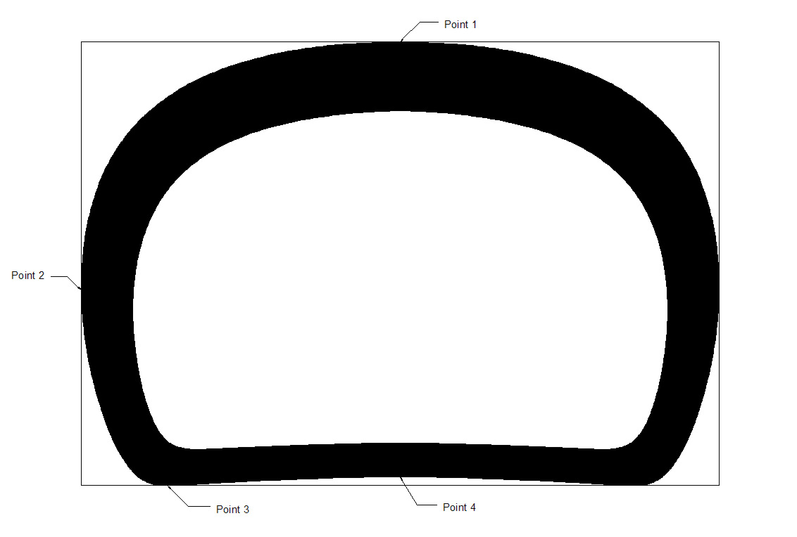Figure 2: Ovoid circumscribed in a rectangle with points of tangency identified.

In order to represent the ovoid curve mathematically we split it horizontally at point 2 (the point of vertical tangency) and deal with the top and bottom separately. The top half of the curve is nearly an ellipse but more closely resembles a rectangle with its sharper corners. This hybrid ellipse is an example of a more general family of curves called a [superellipse](http://en.wikipedia.org/wiki/Superellipse). A **superellipse** (or **Lamé curve**) is a geometric figure defined in the cartesian coordinate system as the set of all points (*x*, *y*) with:

superellipse_equation.png

If m, n > 2 The curve is called a hyperellipse.

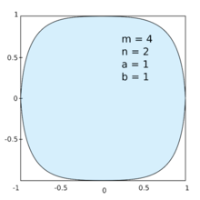

Figure 3: Example of a generalized hyperellipse with m ≠ n.

Note that by adjusting the coefficients (a, b, m, and n) we can adjust the shape of the curve until it very closely approximates our ovoid upper half. Larger values for m and n will make the curve more rectangular, increasing values of a and b will increase the height or width of the overall curve and thereby allow us to also adjust its aspect ratio. Figure 4 below shows a hyper ellipse with a = 4, b = 3, m = 2.2 and n = 2.7.

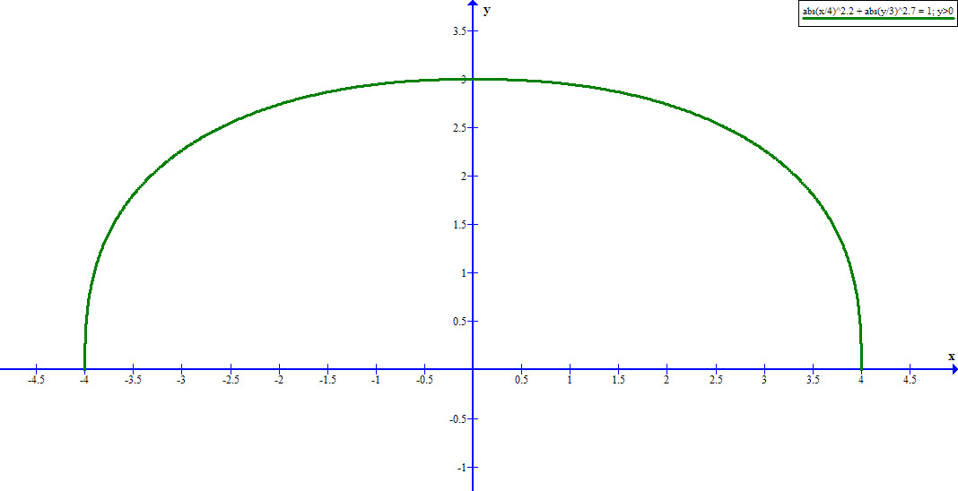Figure 4: Hyperellipse with a = 4, b = 3, m = 2.2, n = 2.7 (where y > 0)

To construct the bottom half of the ovoid requires a bit of algebraic magic so to speak. Actually all we do to create the concave feature of the bottom half is subtract two slightly different hyperellipses from each other, we also add two additional coefficients so that we adjust the concaveness of the resulting curve. The equation is created by first solving for the explicit form of a superellipse and then combining two different expressions for each superellipse into one equation yields the following:

equation1.jpg

Combining graphs of for both top and bottom into one graphic gives us:

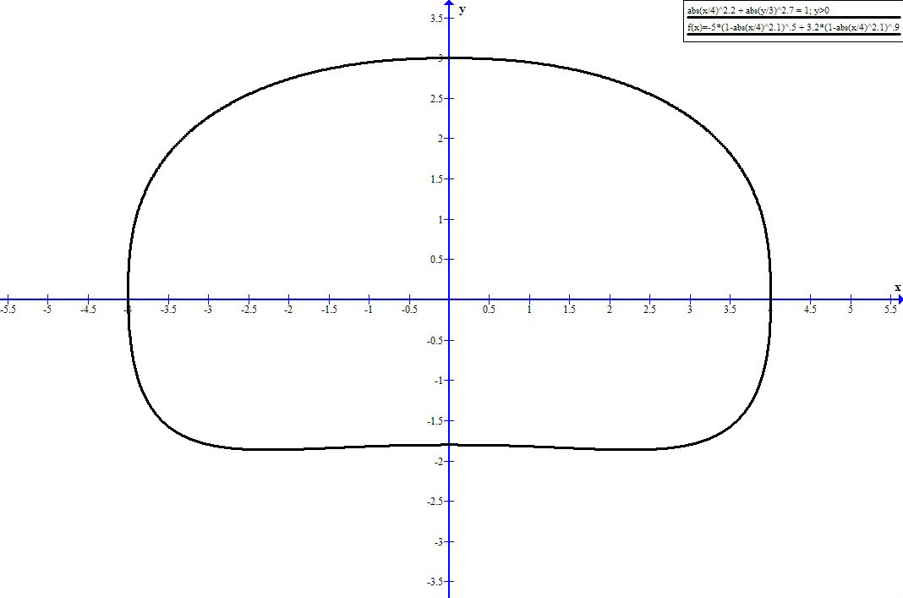

Figure 5: Ovoid approximation with hyperellipses

Note that the resulting curve satisfies all of our tangency requirements as shown in figure 2. Furthermore the resulting curve is perfectly smooth and resembles a more slightly rounded ovoid. With further tweaking of the parameters we generate a more rectangular form:

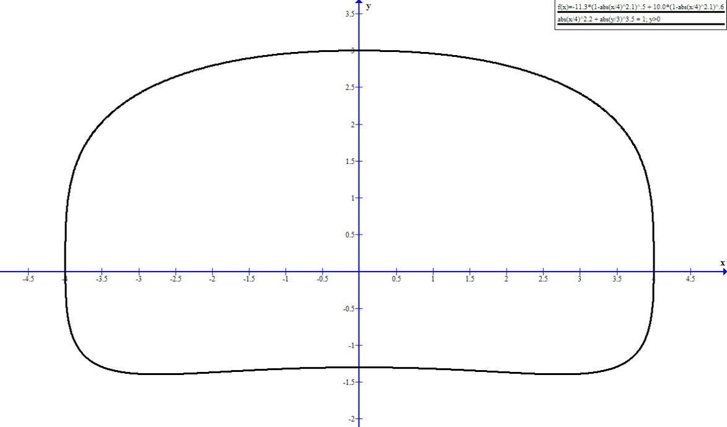

Figure 6: Rectangular hyperellipse approximation

Modifying the coefficients of our equations allows us to approach almost an infinite variety of ovoid forms however from a construction/design standpoint it does not offer us a viable solution for creating ovoids. The process is very tedious and even hard to control. At best we have shown that the ovoid curve is mathematically within our grasp and further characterization should be possible.

The next method I choose to employ was approximation of the ovoid shape with splines or more exactly **NURBS** (Non-uniform rational basis spline). This is the mathematical model commonly used in graphics and drafting programs for generating smooth curves. I normally use Autocad (drafting program) for my own design work however this time I choose Solidworks as my test software due to its extensive parametric capabilities, ease of use and its full featured spline toolbox.

In order to approximate the ovoid in Figure 1 I imported the image into Solidworks and then setup a rectangle around it which after some adjustment properly circumscribed the ovoid as in Figure 2. Next at the points of contact with the rectangle I established three spline control points (points 1, 2, 3), there exact position is determined by the parametric dimensions shown in Figure 7. Finally I setup one control point at the bottom center of the ovoid. Note, that I am only working with one side of the ovoid since the other side is an exact mirror, hence there are only four actual control points. Each control points tangency was constrained to either horizontal or vertical. Then to fine tune the approximation I manually adjusted each control points weighting (note that some are asymetrical as shown by the length of the blue arrows) until I had achieved a very close approximation of the ovoid curve.

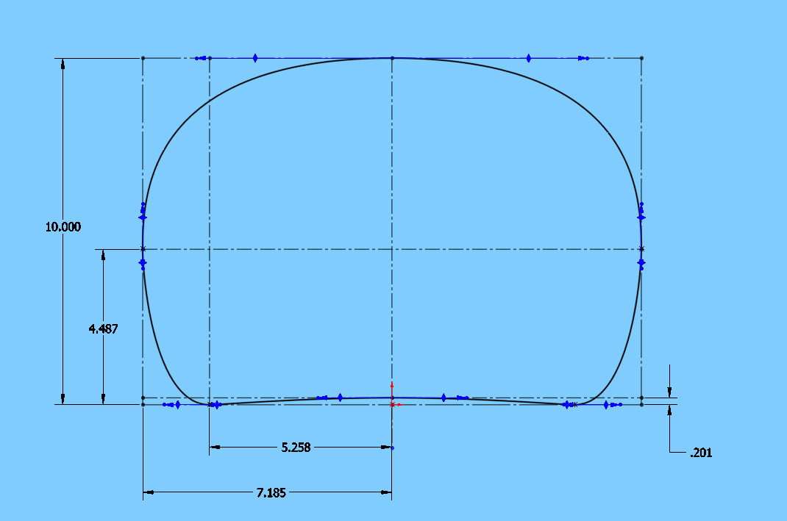

Figure 7: Ovoid constructed with 4 control points using NURBS and Solidworks

Comparing the spline to the original ovoid shows that with four control points we are able to approximate the ovoid shape very closely however where the ovoid has the high degree of curvature (point 3) we find the largest discrepancy, see Figure 8 below (original ovoid is green outline).

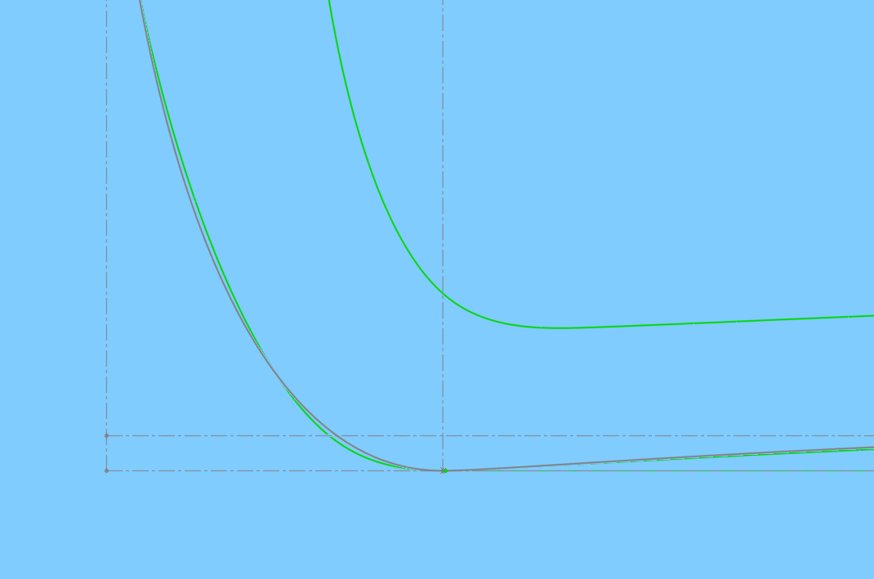

Figure 8: Comparison of Ovoid to 4 point spline at point 3

Our goal is to represent the ovoid with as simple a mathematical model as possible however after trying to approximate a number of ovoids with only four control points I determined that some ovoids could only be properly modeled with 5 control points. With 5 control points we split point 2 into two separate points with tangency vectors that can be adjusted to any value. It should be noted that this increases the complexity of the algorithm quite dramatically since the weights and directions of the two new points must be controlled very carefully to avoid making a “lumpy” ovoid. With the 4 point model, it only requires adjusting weights and dimensions and no possibility of a maladjusted or lumpy ovoid. What we gain is more contol of the shape especially near the sharp bottom corners and also it allows us to control the flatter regions of the curve a bit more precisely.

We can see from comparing Figure 10 to Figure 8 that the 5 point spline allows us to get a little closer to our theoretical ovoid shape. However it did finally occur to me that the reason the 4 point spline could not approximate the ovoid shape was that the ovoid itself was possibly non-smooth. For a vast majority of ovoids the 4 point model seems good enough and for the other 5%-10% the 5 point model should fill the gap.

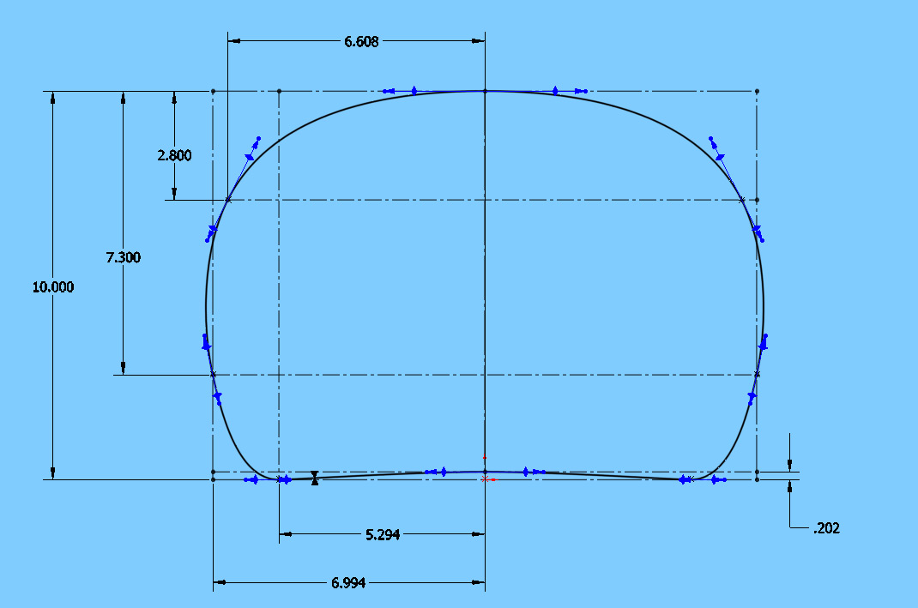

Figure 9: Ovoid constructed with 5 control points using NURBS and Solidworks

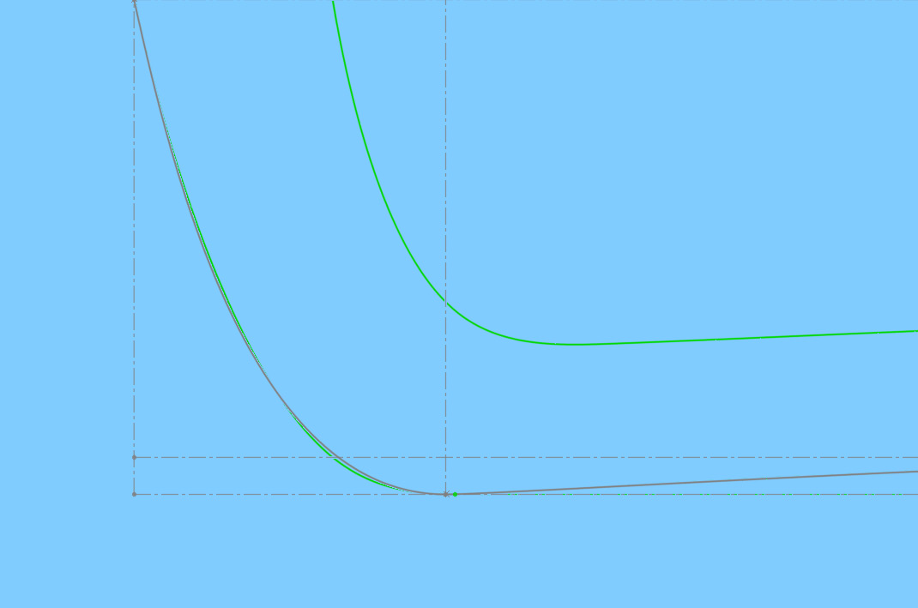

Figure 10: Comparison of Ovoid to 5 point spline at point 3

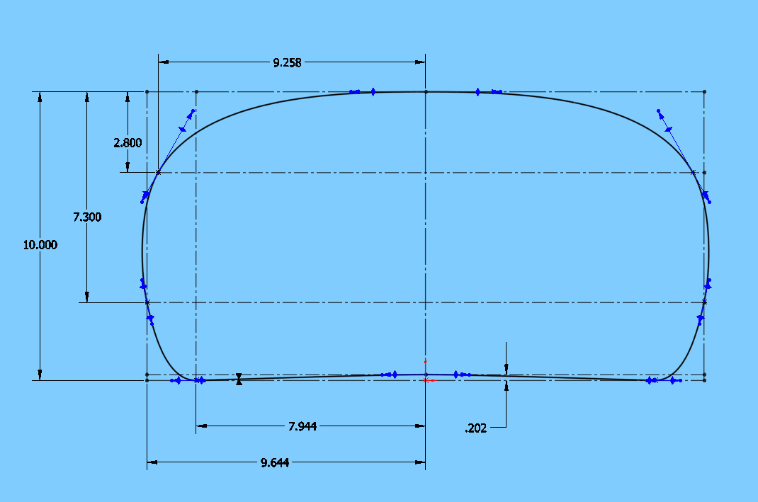

Figure 11: New Ovoid created by adjusting three dimensions

As can be seen in Figure 11 we are now able to easily and quickly create new ovoid templates from an existing template by simply adjusting a few parameters, this case I wanted to created a similar looking ovoid to that in Figure 10 but with a different aspect ratio. To do this I had to only change the three horizontal dimensions of three control points, everything else remained the same, however I could change any or all parameters if desired.

Conclusions

We have shown that the northwest native art ovoid is a mathematical curve that can be characterized using a combination of hyperellipses. We have also demonstrated a means by which to construct ovoid templates or approximate existing ovoid shapes using splines (NURBS). If we scale each ovoid that we construct, such that its overall vertical dimension is unity, we can then record and compare the values of all its parameters (dimensions, control point weights, tangent vector directions). Each ovoid will then have a precise set of values which clearly defines it and makes it unique from all other ovoids. It allows us to talk about and describe an ovoid very precisely. What I am proposing is in a sense is a standard model for the ovoid so that researchers and artists can communicate their work in a more concrete and quantifiable method.

Further Research

After spending the last few years examining numerous works of art by a variety of northwest artists I have also come to the conclusion that each artist (especially those with a large body of work) draws his or her ovoids in a unique way such that it should be possible to characterize a large number of an artists ovoids (especially main body and head ovoids) and then generate an “average” ovoid which represents that artists particular style of ovoid. This could be done for every artist that has a reasonably large body of work, thereby creating a library of ovoid data for all known artists. Once this is done then it should be possible to compare an ovoid from a work of an unknown artist and assigned a probability that it was drawn by a certain artist. It would also be interesting to see if other trends appears such as tribal or geographic location influencing the style and ovoid shape of each artist. Obviously this amount of data collection is beyond the scope of a single individual and is good material for future research however I think it shows the potential and value of the precise characterization of the northwest coast ovoid.